The time independent spherically symmetric solution of the Einstein equation revisited

Jean-Pierre Petit, Gilles d’Agostini and Sebastien Michea ⁺

Manaty Research group

_________________________________________________________________________________________

Key words : Non contractible hypersurface. Throat sphere, space bridge. Spherically symmetric solution.
____________________________________________________________________________________________________

Abstract : Spherical symmetry does not immediately mean central symmetry. The time independent, spherically symmetric solution of the homogeneous Einstein equation is revisited with coordinates which keep the signature invariant and prevent time and radial coordinate interchange. The associated hypersurface is not contractible and corresponds to a space bridge linking two Minkowski spacetimes though a throat sphere. As the determinant of the metric vanishes on that sphere one gets an orbifold structure. When crossing that sphere the particles experience a PT, mass and energy inversions.
____________________________________________________________________________________________________

Introduction and main idea of this article.

In 1916 Karl Schwarzschild publishes [1] a solution of the vacuum Einstein equations (without second term) correspond to time translation invariance and spherical symmetry. It is only in 1999 that an English translation of this article will be available [2] thanks to S.Antoci et A.Loinger. Schwarzschild decides to express this solution by using a first set of real variables

- 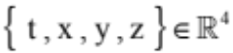

The solution is then given in the form :

(b)

He then introduces an intermediary variable :

(c) 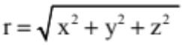

Which, given (a) is essentially positive.

He performs a new coordinates change that allows him to simply express the spherical symmetry hypothesis :

(d)

He then obains the form :
(e)

In order for the metric to be lorentzian at infinity it is necessary that :

(f) 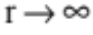 implies 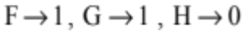

He introduces next a new change of coordinates :

(g) 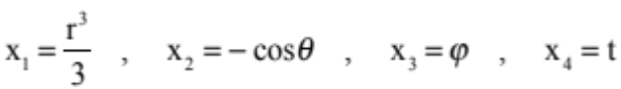

Note that (a) + (c) imply that 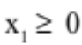

In those new coordinates the metric becomes :

(h) 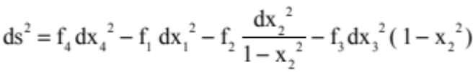

where 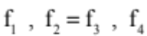 are three functions of 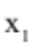 ( hence of r ) that must satisfy the conditions :

- For large : 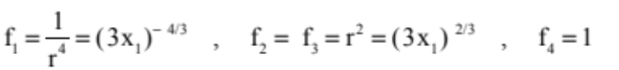

- The determinant 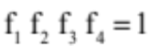

- The metric must be a solution of the field equation.

- Except for 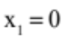 the f functions must be continuous.

His computation leads him to :

(i)

being an integration constant.

Using (g) we can rewrite his solution as :

(j)
That we can rewrite :

(k) 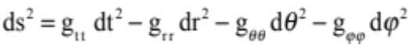

The coefficients 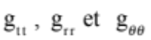are functions of the only variable r, the quantity 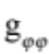being a function of both r and . The variable r varies from 0 to infinity while being strictly positive by definition (c).

Let us limit ourself to the case 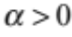 and let consider a path corresponding to dt = dr = 0 . It has a perimeter :

(l) 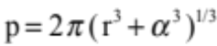

This perimeter has a minimal value 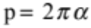 .

The hypersurface solution is therefore non contractible.

The r variable cannot be considered as a « radial distance ». This hypersurface does not have a « centre », the object corresponding to r = 0 hence to à x = y = z = 0 is not a dot but a sphere of radius .

We will now replicate Scharzschild's calculations by replacing the x, y, z and t variables by Greek characters ( is however kept for a later purpose), so that the reader not be tempted to assimilate them to distances (x, y and z) or time (t) and lose sight of what they
really are: real numbers.

Revisiting Schwarzchild computation.

Let us consider the zero second member Einstein equation 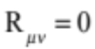 in time independent and spherically symmetrical conditions. Let 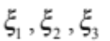 stand for rectangular coordinates, and 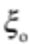 as the time marker, with 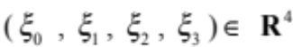 which stands real values for all coordinates. In addition we assume that there are no crossed terms in the line element, so that this last can be written :

(1)
where F , G , H are functions of 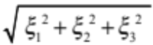 .
At infinity we must have

(2) 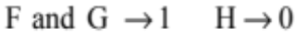

Introduce the following coordinate change :

(3) 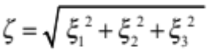
(4) 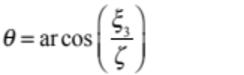
(5) 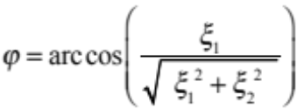
which goes with : 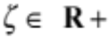 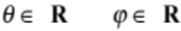 and :

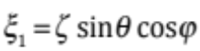 , 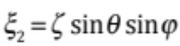 , 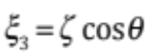
that we will call « pseudo spherical coordinates ». It gives :

(6)

Introduce the following additional coordinate change : :
(7) 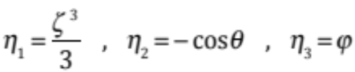
Then we have the volume element 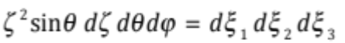. The new variables are then pseudo polar coordinate with the determinant 1. They have the evident advantage of polar coordinates for the treatment of the problem.
In the new pseudo polar coordinates :
(8) 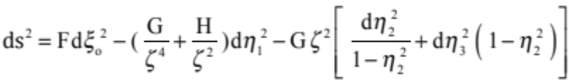
for which we write :
(9) 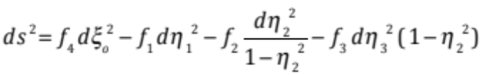
Then f₁ , f₂ = f₃ , f₄ are functions of 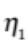 which have to fullfill the following conditions :
1 – For 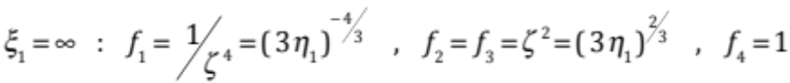
2 – The equation of the determinant : 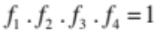
3 – The field equations.
4 – Continuity of the f , except for 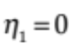
In order to formulate the field equations one must first form the components of the gravitational field corresponding to the line element (9). This happens in the simplest way when one builds the differential equation of the geodesic line by direct execution of the variation, and reads out the components of these. The differential equations of the geodesic line for the line element (9) immediatly result from the variation in the form :
(10)
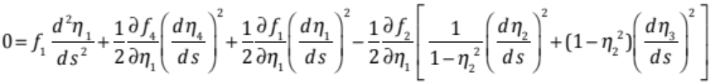
(11)
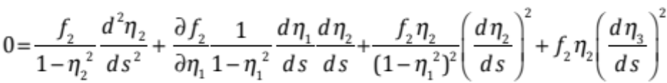
(12)
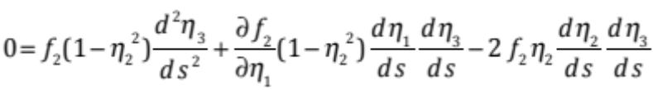
(13)
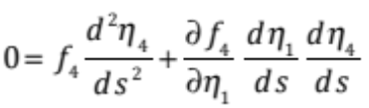
The comparison with
(14)
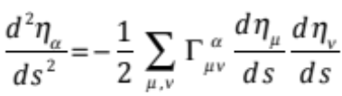

gives the components of the gravitational field :
(15a) 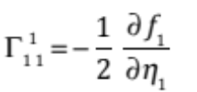
(15b) 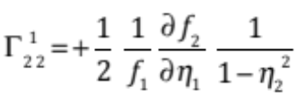
(15c) 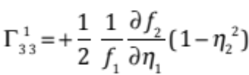
(15d) 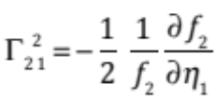
(15e) 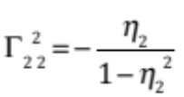
(15f) 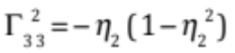
(15g) 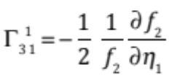
(15h) 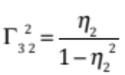
(15i ) 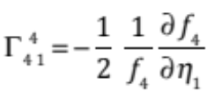
The other ones are zero. Due to rotational symmetry it is sufficient to write the field equations only for the equator 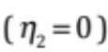, therefore, since they will be differentiated only once, in the previous expressions it is possible to set everywhere since the begining 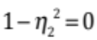 . Then the calculation of the field equation gives :
(16a) 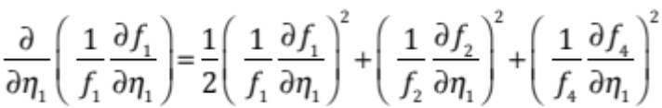
(16b) 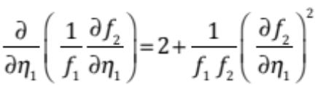
(16c) 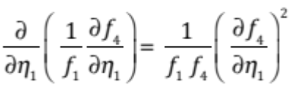

Besides these three equations the functions 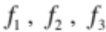 must fullfill the equation of the determinant :
(17) 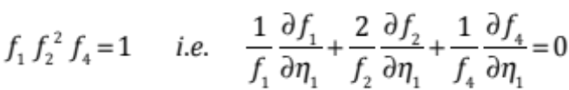
For now we neglect (16b) and determine the three functions 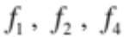 from (16a) , (16c) and (13). The equation (16c) can be transposed into the form :
(18) 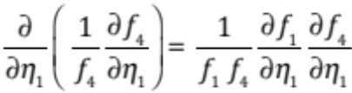
This can be integrated and gives
(19) 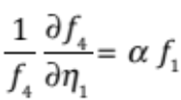 ( being an integration constant )
The addition of (12a) and (12c’) gives :
(20) 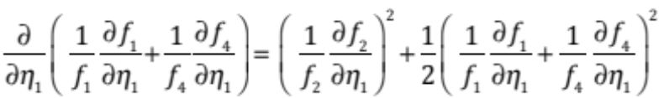
By taking (17) into account we get :
(21) 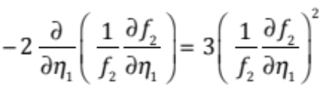
By integrating :

(22) 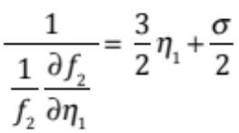 ( integration constant )
or :
(23) 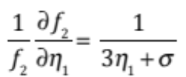
After a second integration :
(24) 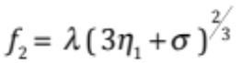 ( integration constant )
The condition at infinity requires = 1 . Then
(19) 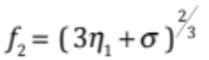
Hence it results further from (22) and (17)
(20) 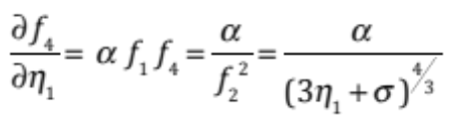
By integrating, while taking account the condition at infinity
(25) 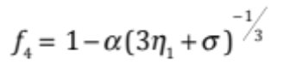
Hence, from (17)
(26) 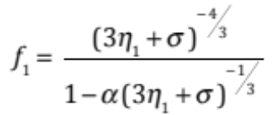
As it can be easily verified the equation (16b) is automatically fullfilled by the expression that we found for f₁ and f₂
Therefore all the conditions are satisfied except the condition of continuity.
f₁ will be discontinuous when 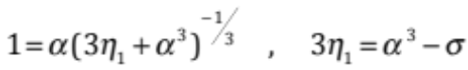
In order this disconinuity coincides with the origin, it must be :
(27) 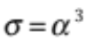
Therefore the condition of continuity relates in this way the two integration constants and . We have :
(28) 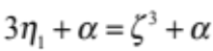
(29) 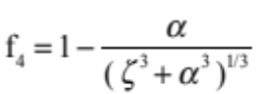
(30) 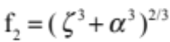
(31) 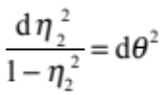
Finally :
(32)
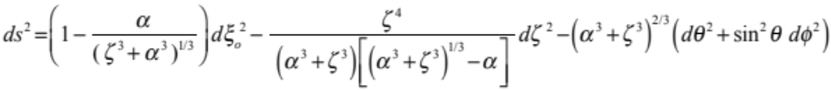
When 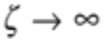 the line element tends to Lorentz form.
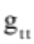 tends to zero when tends to zero.
When 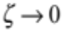 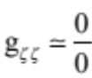 . An expansion into a series shows that 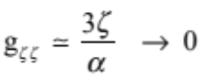
Consider a loop located in the plane 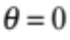 , with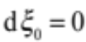 . It is no contractile : for = 0 the perimeter of the loop tends to 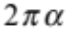 .
Notice that is definitely not a « radius ». The point = 0 does not correspond to some « center of symmetry ». The spherically symmetric requirement does not identify automatically to a central symmetry, as suggested by David Hilbert [5] is just one of the « space markers », nothing else. It’s a number, not a length. The only length to be considered is the quantity s .

Expressing the metric in a better coordinate system.
Let us consider the coordinate system introduced in [3].
Introduce the new space marker through the following coordinate change :
(33) 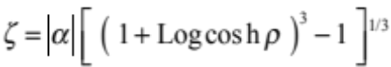
(34) 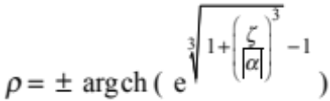
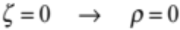
With 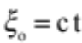 the line element becomes :
(35)
When 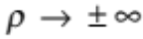 we get the following Lorentz form :
(36)
We can figure this geometrical objet as a space bridge linking two Minkowski spacetimes, though a throat sphere whose perimeter is . We cannot think about its « radius » because that sphere has no center.
When 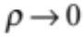
(37) 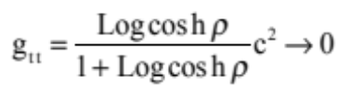
(38) 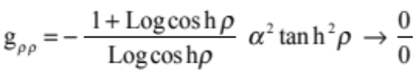
(39) 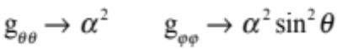
(40) 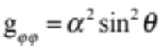
We may easily overcome the indetermination (33) through an expansion into a series, which shows that when 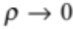
(41) 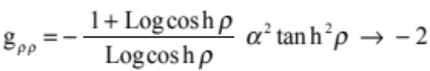
The determinant is :
(42) 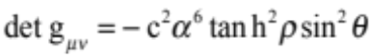
It vanishes on the throat sphere. As a consequence, on this last we cannot define gaussian coordinates, so that the object is no longer a manifold but an orbifold. On the throat sphere the arrow of time and the space orientation cannot ne defined. This can be interpreted as a geometric structure where space and time are reversed through the throat sphere : when a particle crosses the throat sphere it experiences a PT-symmetry. According to Souriau’s theorem [4] this T-inversion goes with a mass inversion.
In a future paper the physical interpretation of such solution will be investigated.

References :
[1] K. Schwarzschild : Über das Gravitionalsfeld einer Kugel Aus incompressibler Flüssigkeit nach der Einsteinschen Theorie. Sitzung der phys. Math. Klasse v.23 märz 1916

[2] K. Schwarzschild : On the gravitational field of a sphere of incompressible fluid according to Einstein theory. Translation by S.Antoci and A.Loinger. arXiv :physics/9905030v1 [physics.hist-ph] 12 may 1999.

[3] J.P.Petit & G.D’Agostini : Cancellation of the singularity of the Schwarzschild solution with natural mass inversion process. Mod. Phys. Lett. A vol. 30 n°9 2015
[4] J.M.Souriau : Structure des systèmes dynamiques. Dunod Ed. France, 1970 and Structure of Dynamical Systems. Boston, Birkhaüser Ed. 1997. For time inversion see page 190 equation (14.67).
[5] D.Hilbert : “Die Grundlagen der Physij. (Zweite Mitteilung)” in Nachchrichten von der Königlichen Gesellschaft zu Göttingen. Math. -Phys. Klasse. 1917 , p.53-76. Presented in the session of 23 december 1916

We quote, page 67 of the german edition : « Die Gravitation 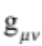 ist zentrisch symmetrisch in Bezug auf den Kooridinatenanfangspunkt. « English translation : « The gravitation is centrally symmetric with respect to the origin of coordinates. »

